Chapter 5, Problem 78

Use PSpice to obtain v_{o} in the circuit of Fig. 5.101.

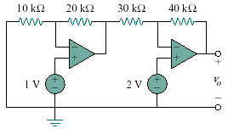
Figure 5.101
For Prob. 5.78.

